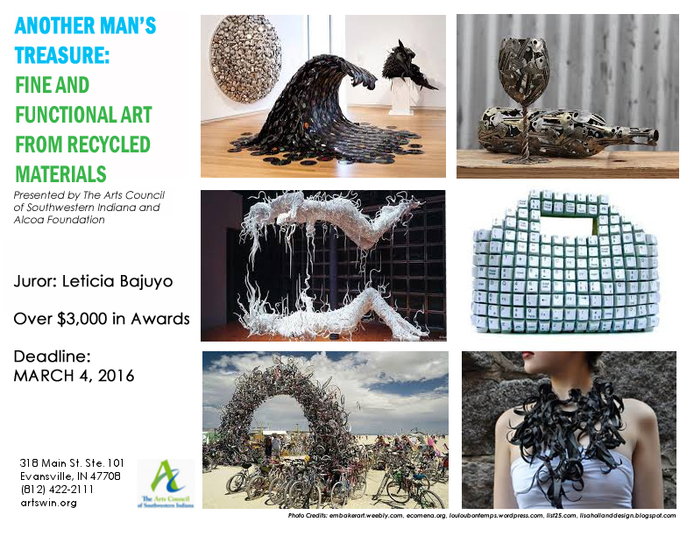
The Arts Council of Southwestern Indiana is requesting artists to submit artwork created from manmade recycled materials. The exhibit will feature work in two categories; Fine Art (art objects intended for display), and Functional Art (art objects designed to be used in daily life, i.e. housewares, furniture, bicycles, etc.).

The Arts Council of Southwestern Indiana would like to thank Alcoa Foundation for making this exhibition possible through its generous funding.

Process:
Works will be considered for inclusion in the exhibit by our juror, Leticia Bajuyo, via digital submission. A completed registration form with hi-resolution jpegs of entries must be emailed to Andrea Adams at andrea.adams@artswin.org no later than 4:00 PM ON MARCH 4, 2016. Work will be juried and notifications will be sent out via email no later than 4:00 PM on March 25, 2016. All pieces that are selected to be a part of the exhibit must be at the Arts Council (318 Main Street, Suite 101, Evansville, IN) by April 18, 2016. Please review the timeline at the bottom of this page for important dates. There is no cost to enter this exhibit.

Media:
Acceptable media must contain a minimum of 75% manmade recycled materials. Our criteria for recycled is using elements that were originally manufactured and would be thrown away, if it were not for your creativity to reformat it in a manner or work of art that is different from its intended original use. Natural materials such as leaves, tree parts, or rocks are not considered recycled. A good criterion is that the materials you use are considered junk, or would have ended up in the landfill if you hadn’t rescued them for art. (Suggestions: Old toys, machine parts, used building materials, newspapers, magazines, fabric from old clothing, CDs, etc.)

Awards:
The Arts Council will grant purchase awards to the Best in Fine Art and Best in Functional Art categories. Awards for 1st, 2nd, & 3rd place will also be granted in each category. The purchase awards will allow the Arts Council to place the selected works in various locations throughout the city during the course of the year.
Functional Art Category
Purchase Award: $1,000
First Place: $300
Second Place: $200
Third Place: $100

Fine Art Category
Purchase Award: $1,000
First Place: $300
Second Place: $200
Third Place: $100

Timeline:
Deadline for registration – MARCH 4, 2016, BY 4:00 PM
Email notification of inclusion – MARCH 11, 2016, BY 4:00 PM
Drop off of work – NO LATER THAN APRIL 4, 2016
Exhibit opens – APRIL 8, 2016
Mid-Exhibit Reception – EARTH DAY, Friday, April 22, 2016, 5:30 pm – 7 pm
Exhibit closes – MAY 6, 2016
Application for Registration (up to two pieces can be entered per artist)
Please type or print clearly – use a separate page if needed

Name_____________________________________________________________________

Address___________________________________________________________________

City, State, Zip______________________________________________________________

Phone__________________________________E-mail______________________________

Title of Work________________________________________________________________

Materials__________________________________________________________________

__________________________________________________________________________

Source of Materials __________________________________________________________

Dimensions (W-H-D) ____________________________ Approx. Weight________________

Price:______

Title of Work________________________________________________________________

Materials__________________________________________________________________

__________________________________________________________________________

Source of Materials __________________________________________________________

Dimensions (W-H-D) ____________________________ Approx. Weight________________

Price:______
Juror: Leticia Bajuyo

Leticia Bajuyo was born in Metropolis, Illinois in 1976. Bajuyo currently creates and works in Southern Indiana where she is a Professor of Art and the Gallery Director of the Greiner Art Gallery at Hanover College. After earning a BFA in sculpture in 1998 from the University of Notre Dame and an MFA in sculpture in 2001 from the University of Tennessee, Knoxville, she moved to Hanover College to join the Art and Art History Department. In January 2016, Bajuyo will be returning to the University of Notre Dame as a Visiting Assistant Professor till May 2017.
A 2012 Indiana Arts Commission Individual Artist Program Grant recipient and 2012 Visual Artists Network Exhibition residency and grant recipient, Bajuyo has had recent solo exhibitions at the New Harmony Gallery of Contemporary Art, New Harmony, Indiana; at Living Arts in Tulsa, Oklahoma; at Gallery H100, Eastfield College, Dallas, Texas; and at Women & Their Work Gallery, Austin, Texas. Recent group exhibitions include Space Landscape, HEREart Gallery, New York, New: Biennial 27 at the South Bend Museum of Art, Indiana; The 7 Borders at the Kentucky Museum of Art and Craft, Louisville, Kentucky; and Transmission at the Blue Star Contemporary Art Museum in San Antonio, Texas. This past summer, Bajuyo installed a permanent, site-specific, suspended sculpture for the South Bend Museum of Art. This December, Bajuyo will be exhibiting in a two-person show at the Ground Floor Gallery in Nashville, Tennessee.
Music devices are a recurring visual in Leticia Bajuyo's artworks for exploring fickle appetites. The compact disc is situated in a technological history of automated devices that read inscriptions and codes to reproduce experience. As old CD's and DVD's are donated, the collection becomes a visually displaced consciousness and collective memory, which is woven into a fabric forming shiny whirlpools and creating sculptures with moments of tension that make visible the thin lines of perception between desire and discard.

