*2012 Arts Awards Nomination Form*

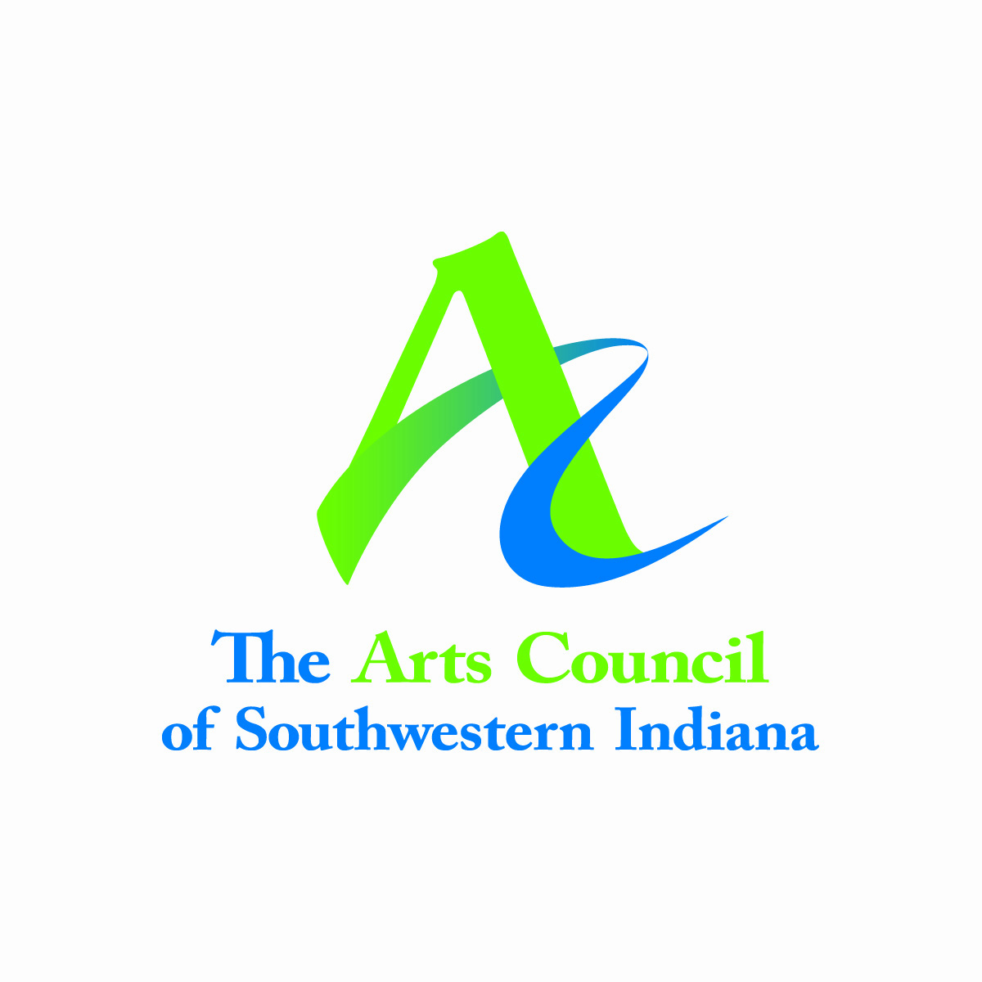

**Nominee**

***I am nominating the following individual, business, or institution:***

Name________________________________________

Address:______________________________________

City/State/Zip:__________________________________

Current title (if applicable):________________________

Company_____________________________________

Business Address:______________________________________

City/State/Zip:__________________________________

Daytime Phone:________________________________

Cell Phone:____________________________________

E-mail:_______________________________________

**Nominator**

Name:________________________________________

Your Title:_____________________________________

Company:_____________________________________

Address:______________________________________

City/State/Zip:__________________________________

Daytime Phone:________________________________

Cell Phone:___________________________________

E-mail:_______________________________________

**NOMINATIONS MUST BE RECEIVED BY 5:00 PM, THURSDAY, MAY 17, 2012.**

**Category / County**

***Check the* ONE *category which is MOST appropriate for your nominee:***

* Mayor’s Arts Award
* Young Artist of the Year
* Artist of the Year
* Arts Educator of the Year
* Arts Advocate of the Year
* Corporate/Institute Arts Award
* Gibson County Arts Award
* Knox County Arts Award
* Pike County Arts Award
* Posey County Arts Award
* Spencer County Arts Award
* Vanderburgh County Arts Award
* Warrick County Arts Award

**Guidelines:**

In describing your nominee, please answer the following questions (Limit 3 paragraphs); page 2 of this form includes the descriptions of the various **award categories**:

1. Why does nominee QUALIFY for the award?
2. List artistic and professional experiences/affiliations
3. How has the community been positively impacted by this nominee’s artistic endeavor?
4. Please e-mail or save to a disc **two** letters of support of the nomination

**Support Documents:**

In addition to the **two** letters of support, up to **three** documents strengthening your nomination can be e-mailed or saved to a disc. (Examples are: digital photos of nominee or art, 3 minute videos, social media pages, websites, newspaper articles, and playbills. **Please e-mail or mail nomination form and disc (if applicable) to:** Arts Council of Southwestern Indiana 318 Main St., Suite 101, Evansville, IN 47708 Phone 812.422.2111 Fax 812.492.4312 **Email:** [**info@artswin.org**](mailto:info@artswin.org)

**Q & A**

***What are the Arts Awards?***

The Arts Council of Southwestern Indiana recognizes individuals, businesses and institutions annually who have made significant contributions to the arts in Gibson, Knox, Pike, Posey, Spencer, Vanderburgh, and Warrick Counties.

***Who is eligible to receive an award?***

Any individual, business or institution from the seven counties served by the Arts Council may be

nominated for these awards. The Mayor’s Arts Award is presented by the Mayor of Evansville, and is restricted to a resident(s) of Vanderburgh County. A past recipient is not eligible to win in the same category again. For a complete list of previous winners, please see the attached (Page 3) or go to our website: www.artswin.org.

***Who may you nominate?***

You may submit nominations for an unlimited number of individuals, however, please submit a separate nomination form for each candidate and check ONLY ONE CATEGORY for each nomination.

***When will the awards be presented?***

Recipients will be notified in advance of a press conference with the Mayor in June and invited to make brief remarks. The Awards Banquet will be Thursday, September 6, 2011 in the Casino Aztar Walnut Room, downtown Evansville.

***Who will make the decisions?***

A Selection Committee comprised of regional arts supporters and past award recipients will select the winners from the pool of nominees for each award.

***What will the recipients receive?***

Each recipient will receive an original artwork by a regional artist created especially for 2011 and will attend the Arts Awards Banquet (accompanied by a guest) at no cost.

***What is the nomination deadline?***

The nomination must be received at the Arts Council office by 5 pm, Thursday, May 17, 2012.

**Award Categories:**

***Mayor’s Arts Award*:**

This highly prestigious honor is given to an individual(s) whose contributions to the arts have had exceptional impact on the community. Consideration is given to evidence of long-standing support and life-long interest in the arts. The nominee must be a current resident of Vanderburgh County, and their arts activities have had the most significant impact on the City of Evansville.

***Young Artist of the Year*:**

A candidate for this award should be a high school junior or senior with exceptional talent in the literary, visual, or performing arts.

***Artist of the Year*:**

A candidate for this award will be considered from any discipline, including literary, performing and visual arts.

***Arts in Education Award*:**

This award recognizes an educator that directly influences and engages students of any age through the visual, literary, or performing arts.

***Arts Advocate of the Year*:**

This award recognizes an individual or organization that provided service, leadership and/or substantial support to the arts.

***Corporate Arts Award*:**

This award honors a business/entity which shows exemplary support of the arts, artists, and arts organizations within our region.

***Regional Arts Award*:**

These awards will be given to an individual, business, or institution from each county of the Region served by the Arts Council. Counties served are Gibson, Knox, Pike, Posey, Spencer, Vanderburgh, and Warrick. Award is based on dedication to the literary, visual, or performing arts.

|  |  |  |  |  |  |  |
| --- | --- | --- | --- | --- | --- | --- |
| **FORMER ARTS AWARDS RECIPENTS** | | | | | | |
| **YEAR** | **Mayor's Arts Award** | **Arts Advocate** | **Arts Educator** | **Artist of the Year** | **Young Artist of the Year** | **Corporate Arts Award** |
| 2011 | Diane Schroeder | Maggie Rapp | Kristi Miller | Dana Taylor | Jonathan Uhr | University of Evansville |
| 2010 | Niel & Karen Ellerbrook | Judy Steenberg | Joseph Uduehi | Stephen Pace | Kelsey Miller | Casino Aztar |
| 2009 | Joan David | John & Ginny Schroeder | Ricki Newman | Michael Aakhus | William Sievern | Deaconess Health Systems |
| 2008 | Howard Abrams | Mary Bower | Lennie Dowhie | Matthew Graham | Justin & Christopher Swader | Acclaim Graphics |
| 2007 | Michael Shoulders | Jim & Barbara Blevins | Kathryn Savia (Kitty) | Janice Greene | Elizabeth Mably | Evansville Public Library |
| 2006 | Karen Donovan Magan | Tucker Publishing / Gayle Begley | Terry Becker | Joe Flauto | Erin Washington | American General Finance |
| 2005 | John David Lutz | James Sanders | Deena Laska-Lewis | Margaret McMullan | Amy Bradford | Fifth Third Bank |
| 2004 | Alfred Savia | Kirsten Wagmeister | Jane Case Vickers | Kathryn Waters | Whitney Oliver | BMS/Mead Johnson Nutritionals |
| 2003 | Bridget Muldoon McDaniel | Dorothea Schlechte | Evv Museum Docents | Joan & Gina Moore | Clay Hassler | Old National Bank |
| 2002 | Sue Schriber | Isabella Fine | Amy Lane | Cedric Hustace | Jennifer Stilwell | No Award Presented |
| 2001 | Carol Abrams | Dorothy Eykamp | Jerry Hoover | Cary Gray | Christopher Bailey | Vectren Corporation |
| 2000 | Tom Wilhelmus | Zeke & Betty Smith | Les Miley | Megan Russell | Todd Vogel | ARC Construction Company |
| 1999 | TempleAirs | Helen Mallette | Mark Snyder | Nelia Kimbrough | Cheryl Sanders | Schnuck's Markets |
| 1998 | Tom Tuley | Jane Owen | John McNaughton | Jerry Baum | Coleen Husk | Dunn Hospitality Group |
| 1997 | Jeanne Suhrheinrich | Nancy DeVoe | Mark Eiffler | Carol Dallinger | Katie Kunkel | Target Stores |
| 1996 | Remig & Pauline Fehn | Nancy Gaunt | David Rodenberg | Les Miley | Julie Abbott | Crescent- Crestline-Wabash Plastics |
| 1995 | Evv Philharmonic Orchestra | Alice May | Robert Berridge | Jim Jackson | Jennifer Reaume | The Evansville Courier |
| 1994 | Jim Blevins | D.W. & Alma Vaughn | Jon Siau | Sue Schriber | Frank McCullough | Welborn Baptist Hospital |
| 1993 | Jack Schriber | Carol Abrams | John David Lutz | Amy Musia | John Crowley | Citizens Bank |
| 1992 | Virginia Schroeder | Ken McCutchan | Suzanne Aiken | Bridget Muldoon | Brice Bunner |  |
| 1991 | Dick Engbers |  |  |  |  |  |
| 1990 | John Streetman |  |  |  |  |  |
| 1989 | Stewart Kershaw |  |  |  |  |  |
| 1988 | Dick Hyatt |  |  |  |  |  |
| 1987 | Elaine Gomoll |  |  |  |  |  |
| 1986 | Rita Eykamp |  |  |  |  |  |
| 1985 | Sigfried Weng |  |  |  |  |  |
| 1983 | Alex & Lois Leich |  |  |  |  |  |
| 1981 | Bill Gumberts |  |  |  |  |  |
| **2006 Special Recongnition Award:**  Roger McBain / Nussmeier Engraving | | | | | | |

|  |  |  |  |  |  |  |  |
| --- | --- | --- | --- | --- | --- | --- | --- |
| **Year** | **Gibson County** | **Knox County** | **Pike County** | **Posey County** | **Spencer County** | **Vanderburgh Co.** | **Warrick County** |
| 2011 | Matt Hart | Amy DeLap | Estelyn Eversoll | New Harmony Gallery of Contemporary Art | William A. Koch (in memoriam) | Jan Stovall | Carolyn Weng |
| 2010 | Bob Zasadny | Hastey Pudding Puppet Co. | David McGuire | Robert Pote | Victor Kupcek | Dean Davis | Alan Jobe |
| 2009 | Red Wick | Vincennes Univ. Alumni Series | Nathan Hook | Laurie & Kent Parker | Spencer County Library | Children's Center for Dance | Judy Morton |
| 2008 | Sue Freudenberg | Old Town Players | Pike County C.A.P.E. | David Rodenberg | Misty Mosby | William & Phyllis Grimm | Curtis Uebelhor |
| 2007 | Leslie Wetzel | Andy Jendrzejewski | Vance Hays | George & Peggy Rapp | Fr. Gavin Barnes O.S.B. | Public Education Fdn. | Suzanne Godeke |
| 2006 | Dr. Marie McCord | Jessica Peters | Natalie Brewster | Robert Lee Blaffer Fdn. | Julia Sermersheim | Communities of Solarbron | Lauren Mazur |
| 2005 | Toyota Motor Manufacturing, Indiana | Twila Black | Luke Decker | Under the Beams | Ralph & Helen Kennedy | Tess Grimm | Warrick Co. Museum |