The Franklin Street Events Association partnered with
The Arts Council of Southwestern Indiana
Call for Artists: Holiday Ornaments 2016

The Christmas-a-Kid Program, an annual charity funded by sales of the ARTSWIN & FSEA’s Holiday Ornaments, purchases under-privileged local area children gifts during the holiday season. ALL proceeds of the 2016 Holiday Ornament Sale will go to FSEA’s Christmas-a-Kid Program.

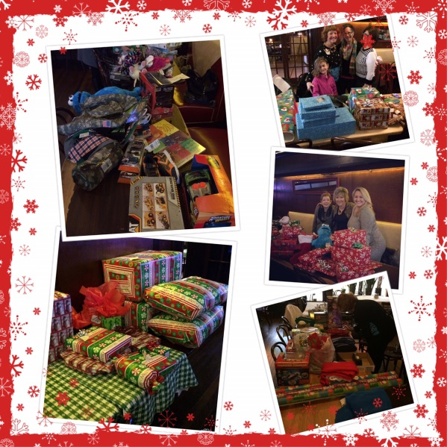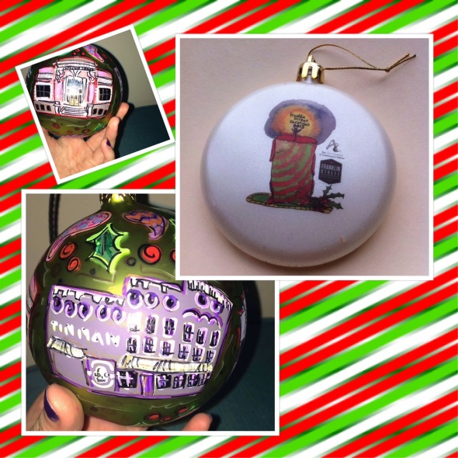

For the third year, an artist’s design will be chosen to be featured on a collectable ornament. The chosen artist will also create 20 handcrafted versions of the design, which will be sold at FSEA’s annual “A Dicken’s Christmas” event on Franklin Street, along with the mass produced ornaments. After production costs and a 10% cut to the artist, all sales will be donated to Christmas-a-Kid Program. The artist can also choose to donate their cut to the cause, and will be invited to help wrap the presents purchased for the adopted families.

Timeline:
October 10th:
Deadline for Registration form & digital submissions (hi-res jpeg of design)
October 17th:
Winner Announced on Facebook and on franklinstreeteventsassociation.com
Dec. 5th:
Mass produced ornaments unveiled and sold at various stores on Franklin Street
Dec. 8th:
Deadline for 20 limited edition ornaments, handcrafted by chosen artist
Dec. 10th:
Arts Council booth selling ornaments at “Dickens Christmas” Winter Bazaar event

GUIDELINES:
• The chosen artist’s work will be featured at the Franklin Street Dickens Christmas event scheduled for Saturday, December 10th, 2016. Artist will be credited by name for the ornament, both on the Arts Council of Southwestern Indiana’s website and the Franklin Street Events Association website. Both organizations will actively promote the design on their social media platforms.

• The chosen artist will create 20 handmade limited edition ornaments to be sold the day of the event. Printed ornaments will be priced at $10. The price on the limited edition ornaments will be higher than the printed ornaments, and will be at the discretion of the FSEA and the Arts Council.

• The chosen artist will receive 10% of ornament sales up to $4,000. However, the artist may choose to forfeit their cut, and donate to the cause.
• All proceeds after production and commission costs will go to the FSEA’s Christmas-a-Kid Program. The chosen artist may choose to forfeit their cut, and donate to the cause.
• There are unlimited entries per artist into the contest, with no fee or membership required to enter.

• The winning ornament design will be photographed for publicity and promotion.

TO ENTER:

Please email the following to andrea.adams@artswin.org
by October 10th, 2016:
1.) Digital image(s) of the artwork in a JPEG format sized between 700 and 1000 pixels.

This does not need to be a professional photograph, but should clearly show pattern, texture, and color detail. Photographs should be in focus, color accurate, lit well, and shot against a neutral background. Depending on the type of design, the chosen artist may be asked to re-submit a clearer image after the selection process.
2.) Artist Name, ornament title, phone number, and email.

