ANOTHER’S TREASURE 2017 PROSPECTUS

The Arts Council of Southwestern Indiana is requesting artists to submit artwork created from manmade recycled materials. The exhibit will feature work in two categories; Fine Art (art objects intended for display), and Functional Art (art objects designed to be used in daily life, i.e. housewares, furniture, bicycles, etc.).

The Arts Council of Southwestern Indiana would like to thank Alcoa Foundation for making this exhibition possible through its generous funding.

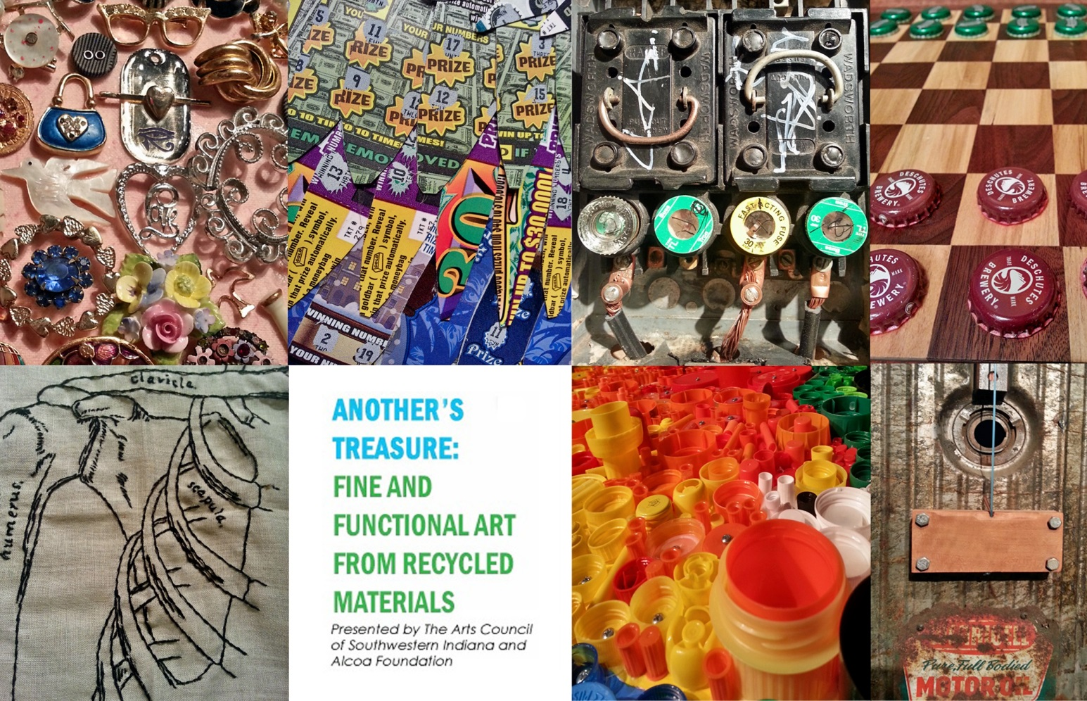

Process:
Works will be considered for inclusion in the exhibit by our juror, Mark Rospenda, via digital submission. A completed registration form with hi-resolution jpegs of entries must be emailed to Andrea Adams at andrea.adams@artswin.org no later than 4:00 PM ON MARCH 17, 2017. Work will be juried and notifications will be sent out via email no later than 4:00 PM on March 31, 2017. All pieces that are selected to be a part of the exhibit must be at the Arts Council (318 Main Street, Suite 101, Evansville, IN) by April 17, 2017. Please review the timeline at the bottom of this page for important dates. There is no cost to enter this exhibit.

Media:
Acceptable media must contain a minimum of 75% manmade recycled materials. Our criteria for recycled is using elements that were originally manufactured and would be thrown away, if it were not for your creativity to reformat it in a manner or work of art that is different from its intended original use. Natural materials such as leaves, tree parts, or rocks are not considered recycled. A good criterion is that the materials you use are considered junk, or would have ended up in the landfill if you hadn’t rescued them for art. (Suggestions: Old toys, machine parts, used building materials, newspapers, magazines, fabric from old clothing, CDs, etc.)

Awards:
The Arts Council will grant purchase awards to the Best in Fine Art and Best in Functional Art categories. Awards for 1st, 2nd, & 3rd place will also be granted in each category. The purchase awards will allow the Arts Council to place the selected works in various locations throughout the city during the course of the year.
Functional Art Category
Purchase Award: $1,000
First Place: $300
Second Place: $200
Third Place: $100

Fine Art Category
Purchase Award: $1,000
First Place: $300
Second Place: $200
Third Place: $100

Timeline:
Deadline for registration – MARCH 17, 2017, BY 4:00 PM
Email notification of inclusion – MARCH 31, 2017, BY 4:00 PM
Drop off of work – NO LATER THAN APRIL 17, 2017
Exhibit opens – APRIL 21, 2017
Opening Reception – Friday, April 21, 2017, 5:30 pm – 7 pm
Exhibit closes – MAY 11, 2017
Pick up of work – MAY 12, 2017

Application for Registration (up to two pieces can be entered per artist)
Please type or print clearly – use a separate page if needed

Name_____________________________________________________________________

Address___________________________________________________________________

City, State, Zip______________________________________________________________

Phone__________________________________E-mail______________________________

Title of Work________________________________________________________________

Materials__________________________________________________________________

__________________________________________________________________________

Source of Materials __________________________________________________________

Dimensions (W-H-D) ____________________________ Approx. Weight________________

Price:______

Title of Work________________________________________________________________

Materials__________________________________________________________________

__________________________________________________________________________

Source of Materials __________________________________________________________

Dimensions (W-H-D) ____________________________ Approx. Weight________________

Price:______

Juror: Mark Rospenda

Mark Rospenda is Curator of Exhibitions and Collections at the South Bend Museum of Art. He has been a part of the SBMA's curatorial staff since March 2010, during which time he has organized and overseen more than 40 exhibitions. In 2013, Rospenda was integral in initiating the ongoing Sightlines exhibitions series, a collaborative project with the Century Center of South Bend, Indiana. In 2014 he began another new exhibitions series at the SBMA, Conversations, which pairs a regional established artist with an established artist from outside of the South Bend community. Between 2015–2016, Rospenda oversaw the reinstallation of the SBMA's permanent collection galleries. He received an M.F.A. from the University of Chicago (2006) and a B.A. from DePaul University (2000). He is also a practicing artist with 2017 solo exhibitions scheduled for DEMO Project, Springfield, IL; and Moreau Galleries, Saint Mary's College, Notre Dame, IN.

