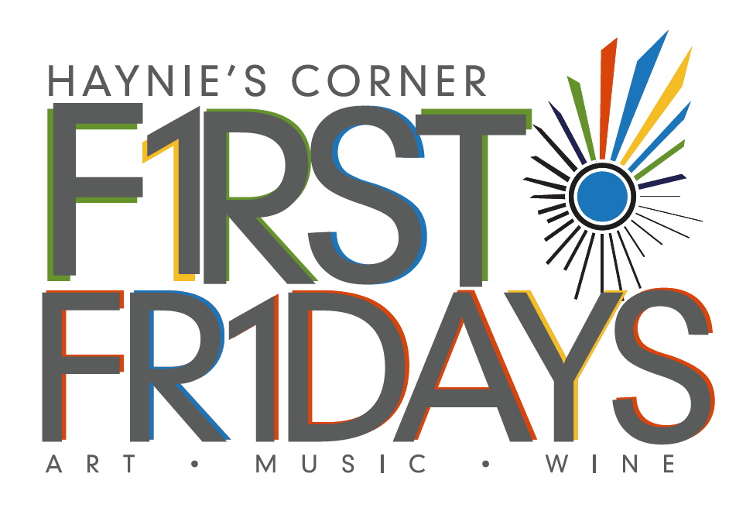
First Fridays
Haynie’s Corner Art District
April - October 2017

ARTIST/PERFORMER APPLICATION
Description: The 2017 Haynie’s Corner Art District First Fridays series is a collaborative effort by the Haynie’s Corner Arts District Association and the Arts Council of Southwestern Indiana. First Fridays events are free, self-guided tours of indoor and outdoor art exhibits and performances, and are designed to highlight local artists and the HCAD businesses hosting them. The event is publicized through print, radio, podcasts, social media, and other media appearances as available.
Participating Businesses will only host the art and the artist on the night of the event unless otherwise arranged between the business and the artist. There is no charge to participate. Artists will be placed based on information from the application. Location requests will be considered, but will not be guaranteed.
Location: Haynie’s Corner Art District
Dates: April 7, May 5, June 2, July 7, August 4, September 1; 6:00-9:00 p.m. each month.
Register: Complete the following form by March 15 and submit to the Arts Council of Southwestern Indiana (318 Main Street, Suite 101, Evansville, IN 47708) or email the completed application to Andrea Adams at andrea.adams@artswin.org.
For marketing purposes, all locations and dates will be finalized prior to the beginning of the 2017 season.

2017 First Friday Series – Artist/Performer Registration
ALL INFORMATION IS REQUIRED TO PARTICIPATE
Contact Information:
[Artist or Organization Name]
[Contact name, if organization]
[Address}
[Email]
[Cell Phone]
[Artist website, social media, etc.]
Visual Artist (See visual artwork information) Performer (See performer information)

Visual Artwork Information:
[Medium]
[2D/3D/Both]
[Approximate price range]
[Do you have access to a tent so that your artwork can be shown outdoors?]
[Any other information that we may need to know to better match you with a business?]

Performer Information:
[What kind of performance will you provide? Ex.) Dance, Theatre, Poetry, etc.]
[Number of participants]
[How much space would you need to perform?]
[Are you able to perform outside, weather permitting?]
[How would you like to be listed in promotional materials?]
[Any other information that we may need to know to better match you with a business?]

Please check the 2017 dates you wish to participate and the type of space you would like available:
April 7 May 5 June 2
July 7 August 4 September 1 All Dates

Artist Placement
The Arts Council of Southwestern Indiana will be placing artists within local businesses. Once the match-up has been made, it is the responsibility of the business and artist(s) to coordinate a time for set-up and pick-up. It is up to the business to decide if they want the artwork to stay at their establishment after the First Friday event.
Participating Artist/Performer Waiver of Liability
By participating in this event, I understand that the participating businesses will not be held liable for any theft or damage to my art. Furthermore, I understand that I will not hold the Arts Council of Southwestern Indiana liable for theft or damage which may occur during the time of this public event. Any agreements made outside of the First Friday event are between the artist and the respective business.

Printed Name: _______________________________________________________________________________________
Signature: ____________________________________________________________________________________________
Business: _____________________________________________________________________________________________
Date: __________________________________________________________________________________________________

