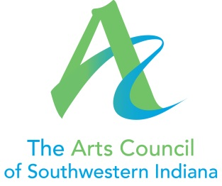

Position Title: Director of Development
Supervisor: Executive Director
Hours: 40 hours/week, to include some evenings and weekends
Purpose: The Director of Development coordinates and manages all development activities of the Arts Council of Southwestern Indiana. A new position in the organization, the Director will work with the Executive Director to build the development program.

Essential Functions:
- Develop and solicit funds through existing Arts Council development programs, including but not limited to:
  - Annual Campaign
  - Corporate Campaign
  - Membership Campaign

- Solicit Sponsorships for programs and special events, including but not limited to:
  - Gallery Exhibits
  - Brown Bag Series
  - Film Festival
  - Classics by Candlelight
  - Civic Theater Underground Series
  - The Mayor’s Arts Awards

- Effectively use social media, email, direct mail, and other communication channels to engage the broader community, developing donors, volunteers, and sponsors.

- Work with the Executive Director, Executive Committee, and Finance Committee to set development goals.

- Work with the Executive Director to identify new funding sources, including individual, corporate, and foundation donors as well as research on new grant opportunities.

- Manage Arts Council grant applications and grant reporting.

- Maintain and manage Donor database and software.

- Maintain and schedule regular and meaningful communication with donors, including donor solicitation and appreciation.

- Work with staff and Committees to develop donor-specific events.

- Perform other duties as assigned by the Executive Director.

Experience
The ideal candidate will have been actively involved in donor development and cultivation, with experience in annual sustaining campaigns, membership programs, and the execution of special events. Experience in major gift development and capitals campaigns preferred.
The ideal candidate will have 5+ years’ experience in non-profit development or related field.
Compensation Competitive

