***Toyota Indiana Mural project***

Toyota Motor Manufacturing, Indiana

Call to Artists Requests for Proposals (RFP)

**Deadline for Submission**

September 17, 2024 at 4:00 p.m. CST. Email submissions only.

**Program Specifics**

The mission of this project is to create a sense of togetherness at the Toyota Motor Manufacturing, Indiana (TMMI) location in Princeton, Indiana. The selected artist or team of artists will prepare the area to be “painted by number” for the public during the Fall Family Day/Open House event on October 5, 2024. The selected artist will be present to help the public during the event and will return later to complete the project. TMMI will supply the paint, and the selected artist or team of artists will be responsible for any other tools they may need.

**Eligibility Requirements**

*Selected artist(s) must:*

* Be 18 years of age or older
* Work as a professional artist or part of an art/design team
* Have previously created public art, large-scale works, or outdoor projects
* Carry personal liability insurance for the on-site duration of the project
* Be willing to meet all contractual obligations and adhere to a strict deadline

**Selection Process**

A committee composed of TMMI representatives and arts professionals will review artists’ proposals and award commissions. Selected artists will work with organizers to further develop designs to fit designated mural sites. The committee reserves the right to reject all submittals.

**Selection Criteria**

*The selected artist will be chosen based upon the following criteria:*

* Work of the highest caliber and effective execution
* Experience of working within *Program Specifics and Selection Criteria*
* Ability to complete work within the specified timeframe and budget
* Visual impact of the proposed mural on the employees of TTMI
* Representation of an artistic vision that acknowledges and embodies the current climate in contemporary public art
* Submissions will not specifically reference TMMI but shall keep in mind the high standards and community involvement that TMMI strives to maintain.
* Appropriateness of content (should be appropriate for all audiences)

**Budget**

* $35,000 for the full scope of work, including design, preparation of the wall space, audience engagement during the event, and completion after the event
* TMMI will supply the paint that meets the standards and safety regulations of the facility. The artist must supply the names of the paint colors and the amount of paint needed.

The artist or team of artists is expected to budget all costs associated with the development and installation of the artwork. This includes supplies (excluding paint), shipping, travel, lodging, equipment, etc. Supplies specific to the artist’s technique or process should be included in artist’s budget.

**Mural Location & Size**

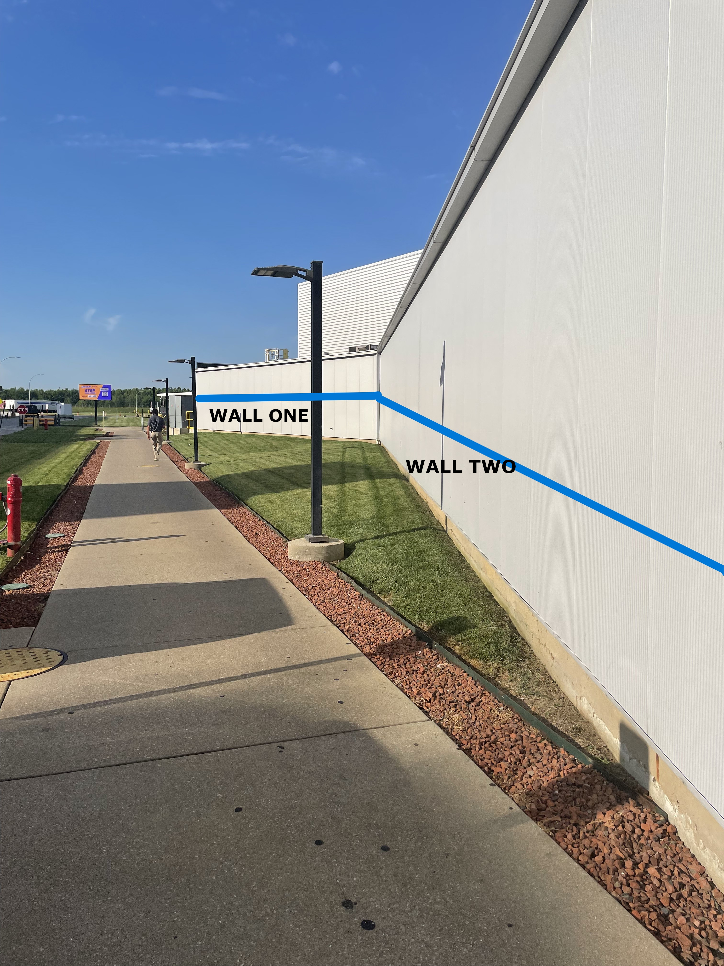

The walls for the mural are located on the TMMI campus, 4000 Tulip Tree Dr, Princeton, IN 47670.

WALL ONE: 58.6’ x 10.75’

WALL TWO: 87.7’ x 10.75’

**Project Timeline**

*The project will follow this timeline:*

* September 17, by 4 p.m. (CDT) Request for Proposals Deadline
* September 19, selection committee reviews proposals
* September 27 by 4 p.m., artists are notified of selection.
* October 1-3, selected artist to prepare the walls for public engagement
* October 5th, selected artist to be present for TTMI’s Fall Family Day and Open House event
* October 7-10, selected artist to touches up and finishes mural
* October 11, mural is complete by the end of the day

**Submission Process**

Artists must submit the following information **via email.**

* **Applicant Information**: Complete the form on the last page of this RFP
* **Statement of Proposal:** This letter should be no longer than one typed letter-sized page using 12-point font and 1-inch margins on all sides. Briefly outline key concepts related to Program Specifics.
* **Professional Resume or CV:** No longer than 4 pages
* **General Budget:** Include a budget outlining all costs involved with the creation & installation of the mural.
* **Proposal Images:** (Digital images – up to 5 images)

*Include copies of muse, sketches, or examples of related or proposed artwork*

* Jpeg or pdf files ONLY
* Good quality, no smaller than 72 dpi
* No larger than 2 MB each
* No hard copies, electronic files only
* Digital mock-ups of artwork. If you are unable to create a mock-up digitally, you may scan your drawings to jpeg or pdf format.
  + - Name your digital files according to the following format: LastName_Concept_01.jpg, LastName_Concept_02.jpg, etc.
* **Previous Work Sample List and Images:** (up to 5 images)

Submit examples of artwork that best represents your experience, style, and ability. You may also submit images of any other work (large scale or otherwise) that best represents your work of the past 5 years. Include a list of work samples and as much information about each of the samples as possible (include name/title of piece, location, medium, process, dimensions, year completed, and any other pertinent information). Here is an example of a Work Sample entry:

1. *Flowers of the Lake*, 234 N. Main St., Evansville, bronze, 1’ x 2’ x 3’, 2014, JavierArtist_01.jpg

Previous Work Images (up to 5 images, same considerations as the proposal images)

Name your submitted digital files according to the following format: FirstLast_01.jpg, FirstLast_02.jpg, etc.

**Delivery of Submissions**

Each artist must submit via email, with subject line “Toyota Mural project”. All submissions must be received by **4:00pm (CDT) on September 17, 2024.**

**Submissions MUST be emailed to:**

Andrea Adams [andrea.adams@artswin.org](mailto:andrea.adams@artswin.org)

Email [andrea.adams@artswin.org](mailto:andrea.adams@artswin.org) with any questions.

For more information about Toyota Motor Manufacturing, Indiana, please visit <https://www.toyotamanufacturing.com/>

**Brand Guidelines and Logo**

A Brand Guidelines document is available upon request to [andrea.adams@artswin.org](mailto:andrea.adams@artswin.org).

*Toyota, Indiana mural project*

Request for Proposal Form

**Applicant Information**

Artist Name:

Mailing Address:

City/State/Zip:

Day Phone:

Email:

Website:

How did you hear about this RFP?